You are invited to a
Flapjack Fundraiser
in support of
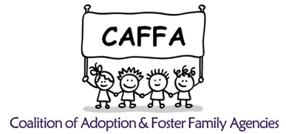

Sunday, September 22, 2019
8:00 a. m.-10:00 a. m.

Applebee’s Neighborhood Grill and Bar
4405 Milestrip Road
Blasdell, NY 14219
Tickets: $6.00

50/50 and Scratch Off Ticket Lottery Tree
Raffle Tickets will be available during the event.

All proceeds to benefit foster/adoptive
children and families in WNY

